Customer Behavior Analysis
Executive Summary
Objective
The objective of this project is to analyze customer transaction data to identify purchasing patterns, customer segments, and churn risks. Exploratory Data Analysis (EDA) and RFM (Recency, Frequency, Monetary) analysis were performed to generate actionable business insights that can support data-driven decision-making.
Dataset
- Dataset: Customer Behavior Analysis Dataset
- Source: Kaggle
- Analysis Tool: Google Colab (Python)
Tools & Libraries Used
- Python
- Pandas
- NumPy
- Matplotlib
- Seaborn
- Google Colab
Methodology
The following steps were performed:
- Data loading and inspection
- Data cleaning
- Missing value analysis
- Duplicate value checking
- Exploratory Data Analysis (EDA)
- Customer behavior visualization
- RFM (Recency, Frequency, Monetary) Analysis
- Customer segmentation
- Correlation analysis
- Business recommendations
Key Findings
- Clothing was the most purchased product category, followed closely by Books.
- Credit Card was the most preferred payment method among customers.
- Customer purchases remained relatively stable throughout the available time period.
- Customer returns and non-returns were nearly equal, suggesting the need to investigate return behaviour.
- RFM analysis identified five customer segments: High Value, Loyal, Potential, At Risk, and Low Value customers.
- Correlation analysis showed only a very weak relationship between Customer Age and Total Purchase Amount, indicating that purchasing behaviour is influenced by multiple factors rather than age alone.
Customer Segments
The RFM analysis classified customers into five groups:
- High Value Customers
- Loyal Customers
- Potential Customers
- At Risk Customers
- Low Value Customers
These segments can help businesses design targeted marketing campaigns and improve customer retention.
Business Recommendations
- Introduce loyalty programmes and exclusive rewards to retain High Value customers.
- Convert Potential customers into Loyal customers through personalised promotions and recommendations.
- Reduce customer churn by identifying At Risk customers and engaging them with targeted offers.
- Increase sales of Electronics and Home products through promotional campaigns and bundled offers.
- Continue using RFM-based customer segmentation to support personalised marketing and data-driven business decisions.
Visualizations
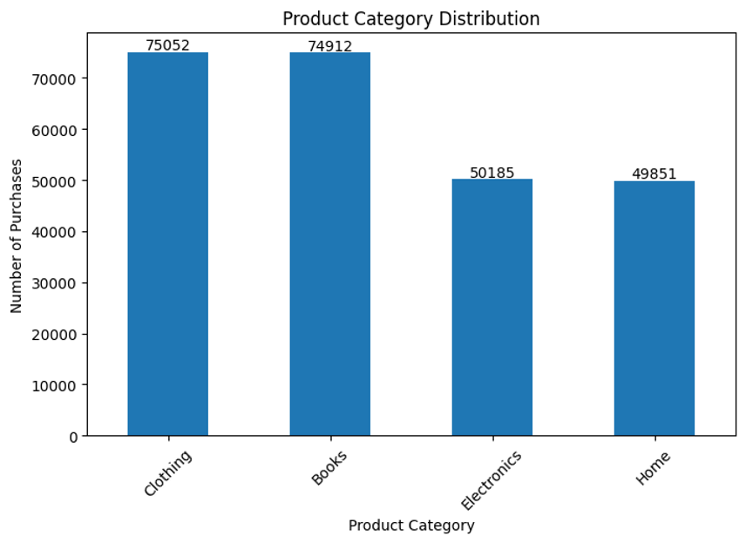

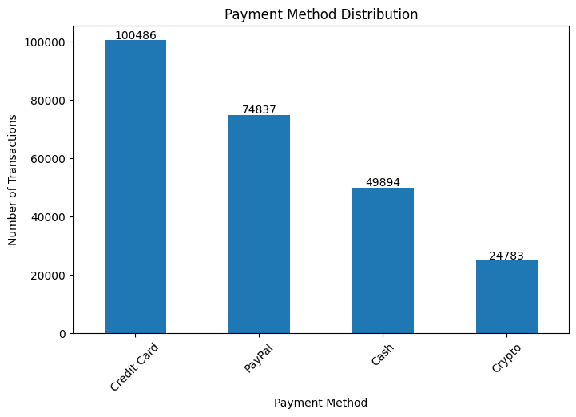
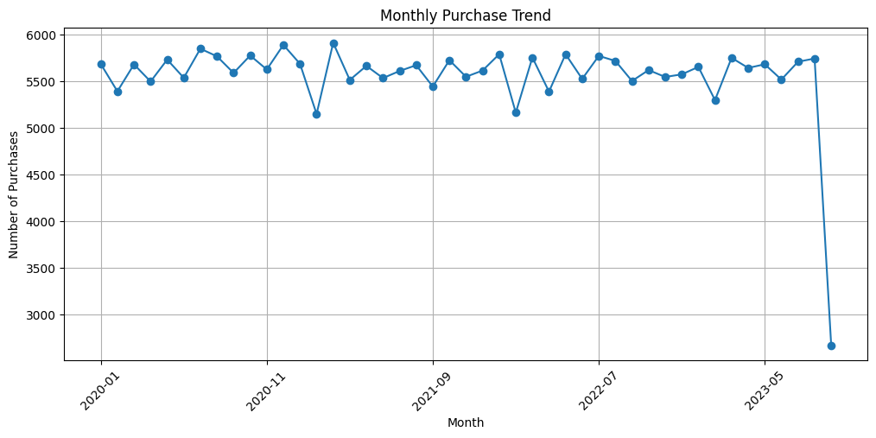

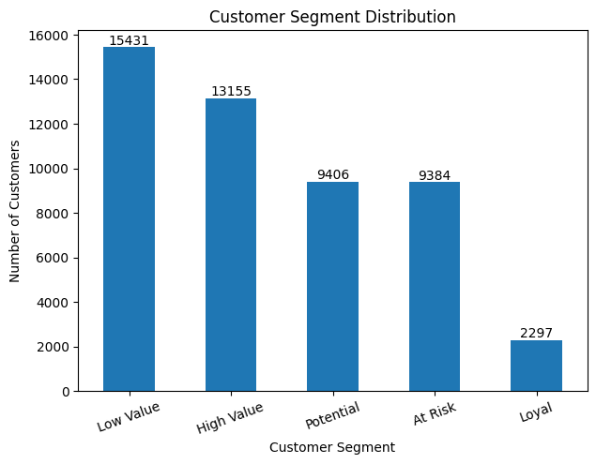

GitHub Repository
Repository Link: https://github.com/pauldebasmita2003-byte/Customer---Behaviour---Analysis
Conclusion
This project successfully analysed customer purchasing behaviour using Python and Exploratory Data Analysis techniques. RFM segmentation provided meaningful insights into customer value and engagement, while the visualizations highlighted purchasing trends and customer preferences. The findings and recommendations can help organisations improve customer retention, optimise marketing strategies, and make informed business decisions.

